IS 350—Prof. Mark G. Simkin Computing Check Digits for ISBN Numbers

Description: The International Standard Book Number (ISBN) used on most American books prior to 2008 uses a weighted code and modulus-11 system to validate ISBN entries. The purpose of this assignment is to create a Visual Basic project that validates such numbers. A suggested user interface is shown below.

An Example: Suppose that a user enters the number 0-7637-2478-5. How can a computer application ensure that this is a valid number? The first step is to strip the “number” of all extraneous dashes, blanks, and similar characters. (Hint: parse the original “number” element by element, and then assemble a new string containing only the numeric values.) For this example, the resulting number is “0763724785.” The second step is to make sure that this new number contains exactly 10 digits. If it does not, there is no need to examine the number further—it is invalid.

If the ISBN contains 10 characters, the third step is to multiply each successive digit in the number by the weights of “10,” “9,” “8,” and so forth, and add the cross-product terms. (Note: an “X” in an ISBN number stands for “10.”) For the current example, this sum is “242” as illustrated below:
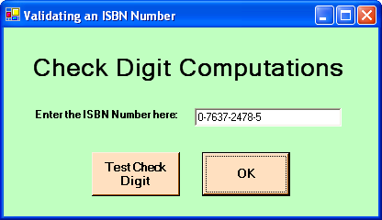
ISBN Number | Weight: | Product:
0 | 10 | 0
7 | 9 | 63
6 | 8 | 48
3 | 7 | 21
7 | 6 | 42
2 | 5 | 10
4 | 4 | 16
7 | 3 | 21
8 | 2 | 16
5 | 1 | 5
Sum: |  | 242
Sum Mod 11: |  | 0

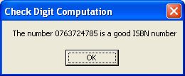
The final step is to examine the sum and verify that this number is evenly divisible by “11”—i.e., to verify that “sum mod 11 = 0.” (Hint: use the Mod function in Visual Basic.) If so, the ISBN number is presumed to be valid. If not, the ISBN is invalid. Your application should provide a message box for each possibility. An example appears to the right.

Problem Deliverables: Document your application with a screen capture of the user interface at run time and a hard copy of your code. Also, test your application using (1) the example above (a valid ISBN number), (2) the ISBN number of your Schneider textbook (also a valid ISBN number), (3) the ISBN number 0-619-21631-X, and (4) an invalid number that you create yourself. Make sure that you enter the ISBN numbers with dashes or blanks. Provide a user interface and the message box for each of these four tests.

For further reading, check this website: www.augustana.ab.ca/%7Emohrj/algorithms/checkdigit.html.

